We will use this text as a model for your text—part of a chapter or article. Note how Carson makes chemistry principles understandable enough for her audience.

Things I would like you to borrow:

Ways of defining and explaining concepts.

Principles of flow and cohesion.

Note that she doesn’t talk down to her readers.

**Cohesion**

1. Known-new contract
2. Immediately answer questions that are likely to pop up in readers’ minds.

At the beginning of sentences, the following moves help you start with known information:

* Synonyms
* Pronouns
* Repeated terms
* Introductory phrases
* Transitional words and phrases (don’t over rely on this)

**3. Elixirs of Death**

FOR THE FIRST TIME in the history of the world, every human being is now subjected to contact with dangerous chemicals, from the moment of conception until death. In the less than two decades of their use, the synthetic pesticides have been so thoroughly distributed throughout the animate and inanimate world that they occur virtually everywhere. They have been recovered from most of the major river systems and even from streams of groundwater flowing unseen through the earth. Residues of these chemicals linger in soil to which they may have been applied a dozen years before. They have entered and lodged in the bodies of fish, birds, reptiles, and domestic and

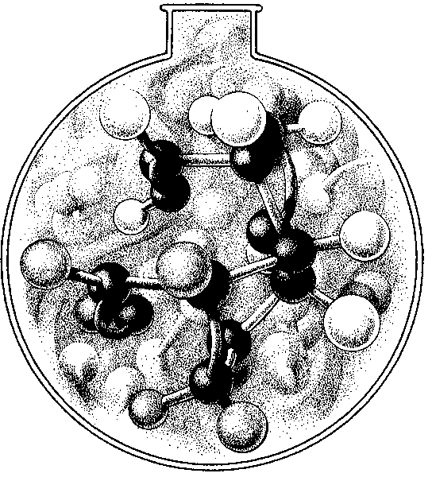

11111

!',,1

I'

,11!

lilll

16 SILENT SPRING



wild animals so universally that scientists carrying on animal experiments find it almost impossible to locate subjects free from such contamination. They have been found in fish in remote mountain lakes, in earthworms burrowing in soil, in the eggs of birds - and in man himself. For these chemicals are now stored in the bodies of the vast majority of human beings, regardless of age. They occur in the mother's milk, and prob­ ably in the tissues of the unborn child.

All this has come about because of the sudden rise and pro­ digious growth of an industry for the production of man-made or synthetic chemicals with insecticidal properties. This industry is a child of the Second World War. In the course of developing agents of chemical warfare, some of the chemicals created in the laboratory were found to be lethal to insects. The discovery did not come by chance: insects were widely used to test chemicals as agents of death for man.

The result has been a seemingly endless stream of synthetic insecticides. In being man-made—by ingenious laboratory manipulation of the molecules, substituting atoms, altering their arrangement—they differ sharply from the simpler insecticides of prewar days. These were derived from naturally occurring minerals and plant products - compounds of arsenic, copper, lead, manganese, zinc, and other minerals, pyrethrum from the dried flowers of chrysanthemums, nicotine sulphate from some of the relatives of tobacco, and rotenone from leguminous plants of the East Indies.

What sets the new synthetic insecticides apart is their enor­ mous biological potency. They have immense power not merely to poison but to enter into the most vital processes of the body and change them in sinister and often deadly ways. Thus, as we shall see, they destroy the very enzymes whose function is to protect the body from harm, they block the oxidation processes from which the body receives its energy, they prevent the nor­ mal functioning of various organs, and they may initiate in cer-

ELIXIRS OF DEATH 17

tain cells the slow and irreversible change that leads to malig­ nancy.

Yet new and more deadly chemicals are added to the list each year and new uses are devised so that contact with these materials has become practically worldwide. The production of synthetic pesticides in the United States soared from 124,- 259,ooo pounds in 1947 to 637,666,000 pounds in 1960- more than a fivefold increase. The wholesale value of these products was well over a quarter of a billion dollars. But in the plans and hopes of the industry this enormous production is only a beginning.

A Who's Who of pesticides is therefore of concern to us all. If we are going to live so. intimately with these chemicals - eating and drinking them, taking them into the very marrow of our bones - we had better know something about their nature and their power.

Although the Second World War marked a turning away from inorganic chemicals as pesticides into the wonder world of the carbon molecule, a few of the old materials persist. Chief among these is arsenic, which is still the basic ingredient in a variety of weed and insect killers. Arsenic is a highly toxic mineral occurring widely in association with the ores of various metals, and in very small amounts in volcanoes, in the sea, and in spring water. Its relations to man are varied and historic. Since many of its compounds are tasteless, it has been a favorite agent of homicide from long before the time of the Borgias to the present. Arsenic is present in English chimney soot and along with certain aromatic hydrocarbons is considered responsible for the carcinogenic (or cancer-causing) action of the soot, which was recognized nearly two centuries ago by an English physician. Epidemics of chronic arsenical poisoning involving whole popu­ lations over long periods are on record. Arsenic-contaminated environments have also caused sickness and death among horses, cows, goats, pigs, deer, fishes, and bees; despite this record arseni-

18 SILENT SPRING



cal sprays and dusts are widely used. In the arsenic-sprayed cot­ ton country of southern United States beekeeping as an industry has nearly died out. Farmers using arsenic dusts over long periods have been afflicted with chronic arsenic poisoning; livestock have been poisoned by crop sprays or weed killers containing arsenic. Drifting arsenic dusts from blueberry lands have spread over neighboring farms, contaminating streams, fatally poisoning bees and cows, and causing human illness. "It is scarcely possible ... to handle arsenicals with more utter disregard of the general health than that which has been practiced in our country in re­ cent years," said Dr. W. C. Hueper, of the National Cancer In­ stitute, an authority on environmental cancer. "Anyone who has watched the dusters and sprayers of arsenical insecticides at work must have been impressed by the almost supreme carelessness with which the poisonous substances are dispensed."

Modern insecticides are still more deadly. The vast majority fall into one of two large groups of chemicals. One, repre­ sented by DDT, is known as the "chlorinated hydrocarbons." The other group consists of the organic phosphorus insecticides, and is represented by the reasonably familiar malathion and parathion. All have one thing in common. As mentioned above, they are built on a basis of carbon atoms, which are also the indispensable building blocks of the living world, and thus classed as "organic." To understand them, we must see of what they are made, and how, although linked with the basic chem­ istry of all life, they lend themselves to **the** modifications which make them agents of death. •

The basic element, carbon, is one whose atoms have an almost infinite capacity for uniting with each other in chains and rings and various other configurations, and for becoming linked with atoms of other substances. Indeed, the incredible diversity of living creatures from bacteria to the great blue whale is largely due to this capacity of carbon. The complex protein molecule

ELIXIRS OF DEATH 19

has the carbon atom as its basis, as have molecules of fat, carbo­ hydrates, enzymes, and vitamins. So, too, have enormous num­ bers of nonliving things, for carbon is not necessarily a symbol of life.

Some organic compounds are simply combinations of carbon and hydrogen. The simplest of these is methane, or marsh gas, formed in nature by the bacterial decomposition of organic matter under water. Mixed with air in proper proportions, methane becomes the dreaded "fire damp" of coal mines. Its structure is beautifully simple, consisting of one carbon atom to which four hydrogen atoms have become attached:

Chemists have discovered that it is possible to detach one or all of the hydrogen atoms and substitute other elements. For example, by substituting one atom of chlorine for one of hydro­ gen we produce methyl chloride:

**H** Cl

*" cl*

/"---

H H

Take away three hydrogen atoms and substitute chlorine and we have the anesthetic chloroform:

\;/

H Cl

Cl/ "c1

20 SILENT SPRING

Substitute chlorine atoms for all of the hydrogen atoms and the result is carbon tetrachloride, the familiar cleaning fluid:

Cl Cl

""- /

**ELIXIRS OF DEATH** 21

myth of the harmlessness of DDT rests on the fact that one of its first uses was the wartime dusting of many thousands of soldiers, refugees, and prisoners, to combat lice. It is widely be­ lieved that since so many people came into extremely intimate

contact with DDT and suffered no immediate ill effects the

Cl/

C

""-Cl

chemical must certainly be innocent of harm. This understand­ able misconception arises from the fact that - unlike other chlo­ rinated hydrocarbons - DDT *in powder form* is not readily

In the simplest possible terms, these changes rung upon the

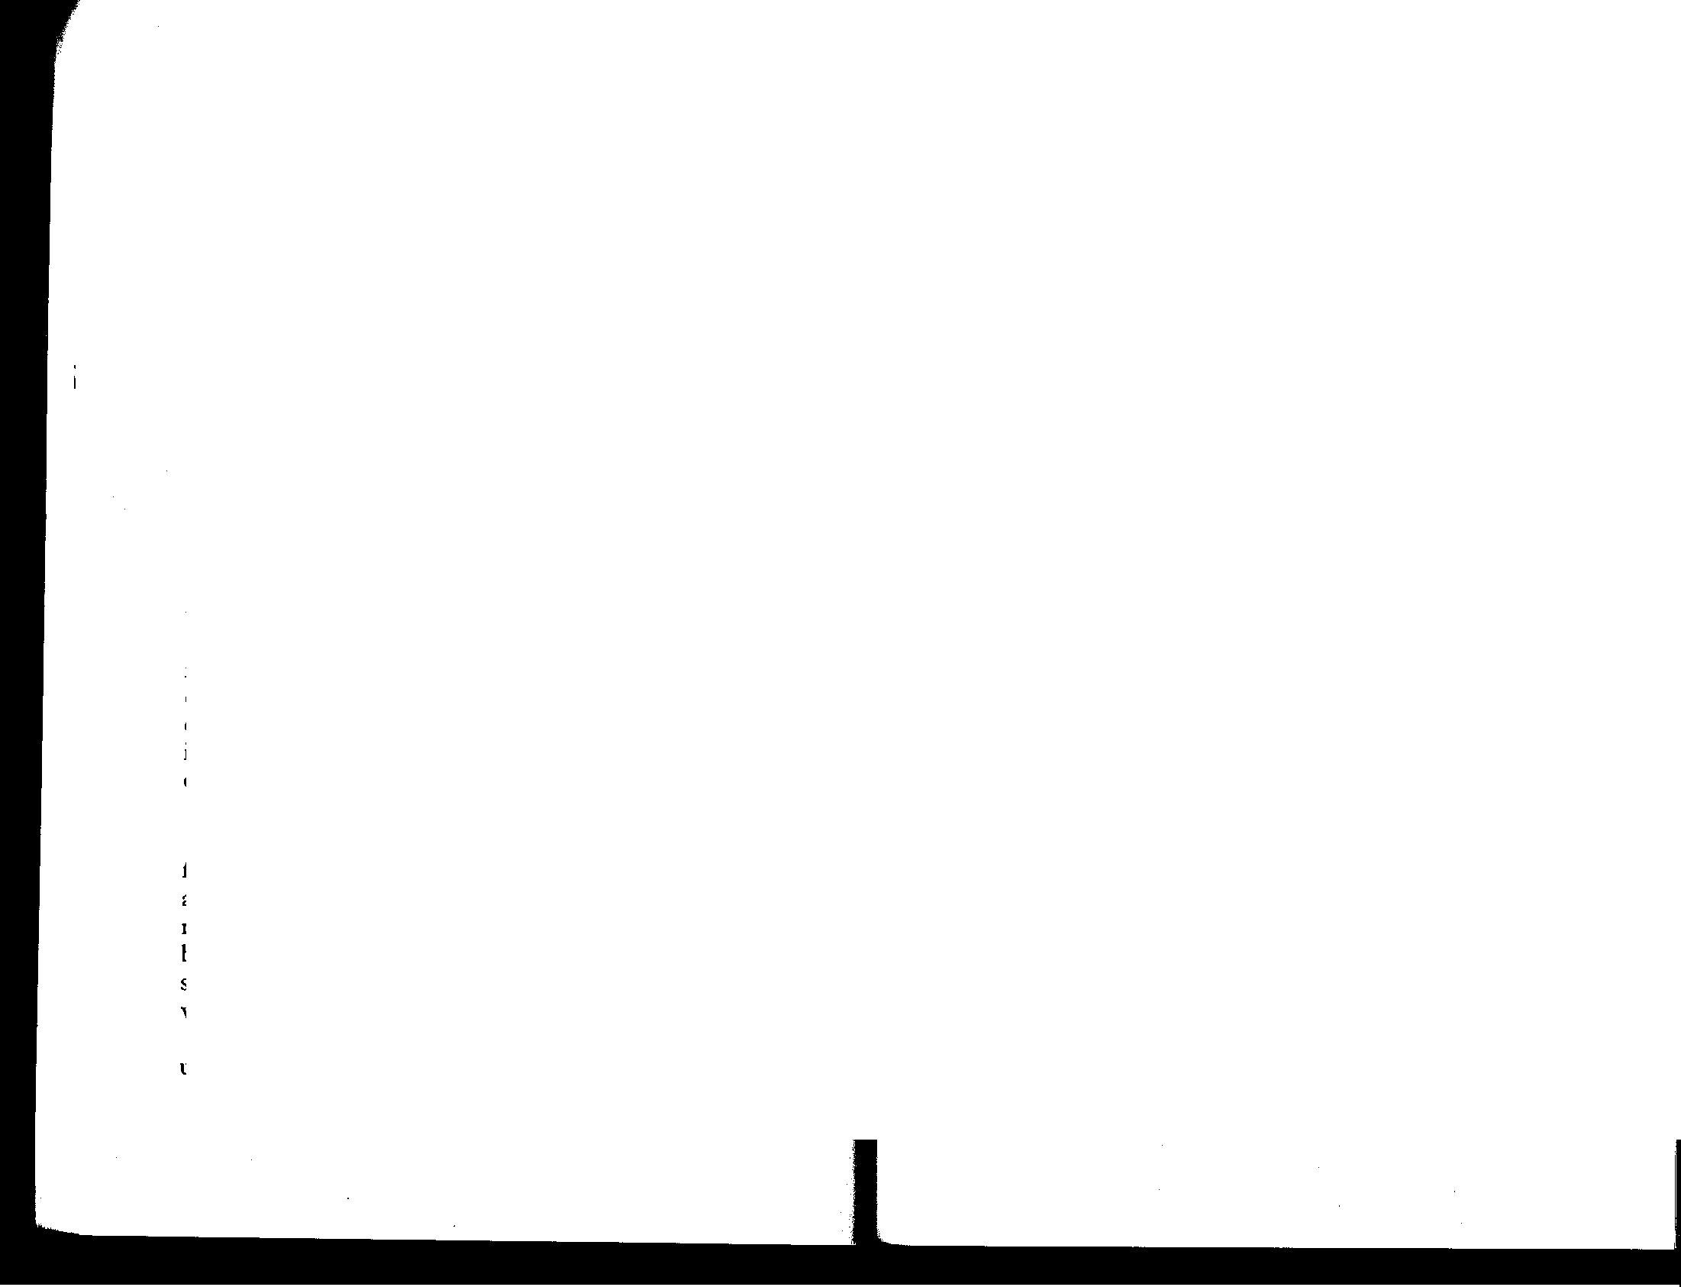

basic molecule of methane illustrate what a chlorinated hydro­ carbon is. But this illustration gives little hint of the true com­ plexity of the chemical world of the hydrocarbons, or of the manipulations by which the organic chemist creates his infinitely varied materials. For instead of the simple methane molecule with its single carbo11 atom, he may work with hydrocarbon molecules consisting of many carbon atoms, arranged in rings or chains, with side chains or branches, holding to themselves with chemical bonds not merely simple atoms of hydrogen or chlorine but also a wide variety of chemical groups. By seemingly slight changes the whole character of the substance is changed; for example, not only what is attached but the place of attachment to the carbon atom is highly important. Such ingenious manipulations have produced a battery of poisons of truly extraordinary power.

DDT (short for dichloro-diphenyl-trichloro-ethane) was first synthesized by a German chemist in 1874, but its properties as an insecticide were not discovered until 1939. Almost immediately DDT was hailed as a means of stamping out insect-borne disease and winning the farmers' war against crop de­ stroyers overnight. The discoverer, Paul Miiller of Switzerland, won the Nobel Prize.

**DDT** is now so universally used that in most minds the prod­ uct takes on the harmless aspect of the familiar. Perhaps the

absorbed through the skin. Dissolved in oil, as it usually is, DDT is definitely toxic. If swallowed, it is absorbed slowly through the digestive tract; it may also be absorbed through the lungs. Once it has entered the body it is stored largely in organs rich in fatty substances (because DDT itself is fat-soluble) such as the adrenals, testes, or thyroid. Relatively large amounts are deposited in the liver, kidneys, and the fat of the large, pro­ tective mesenteries that enfold the intestines.

This storage of DDT begins with the smallest conceivable in­ take of the chemical (which is present as residues on most food­ stuffs) and continues until quite high levels are reached. The fatty storage depots act as biological magnifiers, so that an in­ take of as little as 1/10th of 1 part per million in the diet results in storage of about 10 to 15parts per million, an increase of one hundredfold. or more. These terms of reference, so common­ place to the chemist or the pharmacologist, are unfamiliar to most of us. One part in a million sounds like a very small amount - and so it is. But such substances are so potent that a minute quantity can bring about vast changes in the body. In animal experiments, 3 parts per million has been found to inhibit an essential enzyme in heart muscle; only *5* parts per million has brought about necrosis or disintegration of liver cells; only 2.5 pares per million of the closely related chemicals dieldrin and chlordane did the same.

*1*

This is really not surprising. In the normal chemistry of the human body there is just such a disparity between cause and



You can stop here. Feel free to continue reading, but you

**22 SILENT SPRING**

effect. For example, a quantity of iodine as small as two ten­ thousandths of a gram spells the difference between health and disease. Because these small amounts of pesticides are cumula­ tively stored and only slowly excreted, the threat of chronic

poisoning and degenerative changes of the liver and other organs is very real.

Scientists do not agree upon how much DDT can be stored in the human body. Dr. Arnold Lehman, who is the chief phar­ macologist of the Food and Drug Administration, says there *is* neither a floor below which DDT is not absorbed nor a ceiling beyond which absorption and storage ceases. On the other hand, Dr. Wayland Hayes of the United States Public Health Service contends that in every individual a point of equilibrium is reached, and that DDT in excess of this amount is excreted. For practical purposes it is not particularly important which of these men is right. St0rage in human beings has been well in­ vescigated, and we know that the average person *is* storing potentially harmful amounts. According to various studies, in­ dividuals with no known exposure (except the inevitable dietary one) store an average of 5.3 parts per million to 7 .4 parts per million; agricultural workers z 7. z parts per million; and workers in insecticide plants as high as 648. parts per million! So the range of proven storage is quite wide and, what is even more to the point, the minimum figures are above the level at which damage to the liver and other organs or tissues may begin.

One of the most sinister features of DDT and related chem­ icals is the way they are passed on from one organism to an­ other through all the links of the food chains. For example, fields of alfalfa are dusted with DDT; meal is later prepared from the alfalfa and fed to hens; the hens lay eggs which contain DDT. Or the hay, containing residues of 7 to 8 parts per million, may be fed to cows. The DDT will turn up in the milk in the amount of about 3 parts per million, but in butter made from this milk the concentration may run to *6*5 parts per

ELIXIRS OF DEATH 23

million. Through such a process of transfer, what started out as a very small amount of DDT may end as a heavy concentra­ tion. Farmers nowadays find it difficult to obtain uncontaminated fodder for their milk cows, though the Food and Drug Administration forbids the presence of insecticide residues in milk shipped in interstate commerce.

The poison may also be passed on from mother to offspring. Insecticide residues have been recovered from human milk in samples tested by Food and Drug Administration scientists. This means that the breast-fed human infant is receiving small but regular additions to the load of toxic chemicals building up in his body. It is by no means his first exposure, however: there is good reason to believe this begins while he is still in the womb. In experimental animals the chlorinated hydrocarbon insecticides freely cross the barrier of the placenta, the tradi­ tional protective shield between the embryo and harmful sub­ stances in the mother's body. While the quantities so received by human infants would normally be small, they are not un­ important because children are more susceptible to poisoning than adults. This situation also means that today the average individual almost certainly starts life with the first deposit of the growing load of chemicals his body will be required to carry thenceforth.

All these facts - storage at even low levels, subsequent ac­ cumulation, and occurrence of liver damage at levels that may easily occur in normal diets, caused Food and Drug Administra­ tion scientists to declare as early as z *950* that it is "extremely likely the potential hazard of DDT has been underestimated." There has been no such parallel situation in medical history. No one yet knows what the ultimate consequences may be.

Chlordane, another chlorinated hydrocarbon, has all these un­ pleasant attributes of DDT plus a few that are peculiarly its own. Its residues are long persistent in soil, on foodstuffs, or on



24 SILENT SPRING

surfaces to which it may be applied. Chlordane makes use of all available portals to enter the body. It may be absorbed through the skin, may be breathed in as a spray or dust, and of course is absorbed from the digestive tract if residues are swallowed. Like all other chlorinated hydrocarbons, its deposits build up in the body in cumulative fashion. A diet containing such a small amount of chlordane as 2.5 parts per million may eventually lead to storage of 7*5* parts per million in the fat of experimental animals.

So experienced a pharmacologist as Dr. Lehman has de­ scribed chlordane in 1950 as "one of the most toxic of insecti­ cides - anyone handling it could be poisoned." Judging by the carefree liberality with which-dusts for lawn treatments by sub­ urbanites are laced with chlordane, this warning has not been taken to heart. The fact that the suburbanite is not instantly stricken has little meaning, for the toxins may sleep long in his body, to become manifest months or years later in an obscure disorder almost impossible to trace to its origins. On the other hand, death may strike quickly. One victim who accidentally spilled a 2*5* per cent industrial solution on the skin developed symptoms of poisoning within 40 minutes and died before medical help could be obtained. No reliance can be placed on receiving advance warning which might allow treatment to be had in time.

Heptachlor, one of the constituents of chlordane, is marketed

as a separate formulation. It has a particularly high capacity for storage in fat. If the diet contains as little as ½o of, part per million there will be measurable amounts of heptachlor in the body. It also has the curious ability to undergo change into a chemically distinct substance known as heptachlor epoxide. It does this in soil and in the tissues of both plants and animals. Tests on birds indicate that the epoxide that results from this change is more toxic than the original chemical, which in tum is four times as toxic as chlordane.

ELIXIRS OF DEATH 25

As long ago as the mid-193o's a special group of hydrocar­ bons, the chlorinated naphthalenes, was found to cause hepa­ titis, and also a rare and almost invariably fatal liver disease in persons subjected to occupational exposure. They have led to illness and death of workers in electrical industries; and more recently, in agriculture, they have been considered a cause of a mysterious and usually fatal disease of cattle. In view of these antecedents, it is not surprising that three of the insecticides that are related to this group are among the most violently poisonous of all the hydrocarbons. These are dieldrin, aldrin, and endrin.

Dieldrin, named for a German chemist, Diels, is about *5* times as toxic as DDT when swallowed but 40 times as toxic when absorbed through the skin in solution. It is notorious for strik­ ing quickly and with terrible effect at the nervous system, send­ ing the victims into convulsions. Persons thus poisoned recover so slowly as to indicate chronic effects. As with other chlo­ rinated hydrocarbons, these long-term effects include severe damage to the liver. The long duration of its residues and the effective insecticidal action make dieldrin one of the most used insecticides today, despite the appalling destruction of wildlife that has followed its use. As tested on quail and pheasants, it has proved to be about 40 to *50* times as toxic as **DDT.**

There are vast gaps in our knowledge of how dieldrin is

stored or distributed in the body, or excreted, for the chemists' ingenuity in devising insecticides has long ago outrun biological knowledge of the way these poisons affect the living organism. However, there is every indication of long storage in the human body, where deposits may lie dormant like a slumbering volcano, only to flare up in periods of physiological stress when the body draws upon its fat reserves. Much of what we do know has been learned through hard experience in the antimalarial campaigns carried out by the World Health Organization. As soon as dieldrin was substituted for DDT in malaria-control work (be­ cause the malaria mosquitoes had become resistant to DDT),

SILENT SPRING

cases of poisoning among the spraymen began to occur. The seizures were severe - from half to all ( varying in the different programs) of the men affected went into convulsions and sev­ eral died. Some had convulsions as long as *four months* after the last exposure.

Aldrin is a somewhat mysterious substance, for although it exists as a separate entity it bears the relation of alter ego to dieldrin. When carrots are taken from a bed treated with aldrin they are found to contain residues of dieldrin. This change occurs in living tissues and also in soil. Such alchemistic trans­ formations have led to many erroneous reports, for if a chemist, knowing aldrin has been applied, tests for it he will be deceived into thinking all residues have been dissipated. The residues are there, but they are dieldrin and this requires a different test.

Like dieldrin, aldrin is extremely toxic. It produces degen­ erative changes in the liver and kidneys. A quantity the size of

an aspirin tablet is enough to kill more than 400 quail. Many ' cases of human poisonings are on record, most of them in con­ nection with industrial handling.

Aldrin, like most of this group of insecticides, projects a menacing shadow into the future, the shadow of sterility. Pheas­ ants fed quantities too small to kill them nevertheless laid few

. eggs, and the chicks that hatched·Soon died. The effect is not confined to birds. Rats exposed to aldrin had fewer pregnan­ cies and their young were sickly and short-lived. Puppies born of treated mothers died within three days. By orie means or an­ other, the. new generations suffer for the poisoning of their parents. No one knows whether the same effect will be seen in human beings, yet this chemical has been sprayed from airplanes over suburban areas and farmlands.

Endrin is the most toxic of all the chlorinated hydrocarbons. Although chemically rather closely related to dieldrin, a little twist in its molecular structure makes it *5* times as poisonous. It makes the progenitor of all this group of insecticides, DDT,

We will cover the materi al up to this page. Feel free to read on, but you are respon sible for only materi al up to this page.

ELIXIRS OF DEATH

seem by comparison almost harmless. It is 1 *5* times as poisonous as DDT to mammals, 30 times as poisonous to fish, and about

300 times as poisonous to some birds.

In the decade of its use, endrin has killed enormous numbers of fish, has fatally poisoned cattle that have wandered into sprayed orchards, has poisoned wells, and has drawn a sharp warning from at least one state health department that its care­ less use is endangering human lives.

In one of the most tragic cases of endrin poisoning there was no apparent carelessness; efforts had been made to take pre­ cautions apparently considered adequate. A year-old child had been taken by his American parents to live in Venezuela. There were cockroaches in the house to which they moved, and after a few days a spray containing endrin was used. The baby and the small family dog were taken out of the house before the spraying was done about nine o'clock one morning. After the spraying the floors were washed. The baby and dog were re­ turned to the house in midafternoon. An hour or so later the dog vomited, went into convulsions, and died. At rn P.M. on the evening of the same day the baby also vomited, went into convulsions, and lost consciousness. After that fateful contact with endrin, this normal, healthy child became little more than a vegetable - unable to see or hear, subject to frequent mus­ cular spasms, apparently completely cut off from contact with his surroundings. Several months of treatment in a New York hospital failed to change his condition or bring hope of change. "It is extremely doubtful," reported the attending physicians, "that any useful degree of recovery will occur."

The second major group of insecticides, the alkyl or organic phosphates, are among the most poisonous chemicals in the world. The chief and most obvious hazard attending their use is that of acute poisoning of people applying the sprays or ac­ cidentally coming in contact with drifting spray, with vegeta-



28 SILENT SPRING



tion coated by it, or with a discarded container. In Florida, two children found an empty bag and used it to repair a swing. Shortly thereafter both of them died and three of their play­ mates became ill. The bag had once contained an insecticide called parathion, one of the organic phosphates; tests established death by parathion poisoning. On another occasion two small boys in Wisconsin, cousins, died on the same night. One had been playing in his yard when spray drifted in from an adjoin­ ing field where his father was spraying potatoes with parathion; the other had run playfully into the barn after his father and had put his hand on the nozzle of the spray equipment.

The origin of these insecticides has a certain ironic signifi­ cance. Although some of the chemicals themselves - organic esters of phosphoric acid - had been known for many years, their insecticidal properties remained to be discovered by a German chemist, Gerhard Schrader, in the late I93o's. Almost immediately the German government recognized the value of these same chemicals as new and devastating weapons in man's war against his own kind, and the work on them was declared secret. Some became the deadly nerve gases. Others, of closely allied structure, became insecticides.

The organic phosphorus insecticides act on the living organ­ ism in a peculiar way. They have the ability to destroy enzymes

- enzymes that perform necessary functions in the body. Their target is the nervous system, whether the victim is an insect or a warm-blooded animal. Under normal conditions, an impulse passes from nerve to nerve with the aid of a "chemical trans­ mitter" called acetylcholine, a substance that performs an essen­ tial function and then disappears. Indeed, its existence is so ephemeral that medical researchers are unable, without special procedures, to sample it before the body has destroyed it. This transient nature of the transmitting chemical is necessary to the normal functioning of the body. If the acetylcholine is not destroyed as soon as a nerve impulse has passed, impulses con-

ELIXIRS OF DEATH 29

tinue to flash across the bridge from nerve to nerve, as the chemical exerts its effects in an ever more intensified manner. The movements of the whole body become uncoordinated: tremors, muscular spasms, convulsions, and death quickly result.

This contingency has been provided for by the body. A pro­ tective enzyme called cholinesterase is at hand to destroy the transmitting chemical once it is no longer needed. By this means a precise balance is struck and the body never builds up a dangerous amount of acetylcholine. But on contact with the organic phosphorus insecticides, the protective enzyme is de­ stroyed, and as the quantity of the enzyme is reduced that of the transmitting chemical builds up. In this effect, the organic phosphorus compounds resemble the alkaloid poison muscarine, found in a poisonous mushroom, the fly amanita.

Repeated exposures may lower the cholinesterase level until an individual reaches the brink of acute poisoning, a brink over which he may be pushed by a very small additional exposure. For this reason it is considered important to make periodic ex­ aminations of the blood of spray operators and others regularly exposed.

Parathion is one of the most widely used of the organic phos­ phates. It is also one of the most powerful and dangerous. Honeybees become "wildly agitated and bellicose" on contact with it, perform frantic cleaning movements, and are near death within half an hour. A chemist, thinking to learn by the most direct possible means the dose acutely toxic to human beings, swallowed a minute amount, equivalent to about .00424 ounce. Paralysis followed so instantaneously that he could not reach the antidotes he had prepared at hand, and-so he died. Parathion is now said to be a • favorite instrument of suicide in Finland. In recent years the State of California has reported an average of more than zoo cases of accidental parathion poisoning an­ nually. In many parts of the world the fatality rate from para-

30 SILENT SPRING



thion is startling: 100 fatal cases in India and 67 in Syria in 1958,

and an average of 336 deaths per year in Japan.

Yet some 7,000,000 pounds of parathion are now applied to fields and orchards of the United States - by hand sprayers, motorized blowers and dusters, and by airplane. The amount used on California farms alone could, according to one medical authority, "provide a lethal dose for *5* to 10 times the whole world's population."

One of the few circumstances that save us from extinction by this means is the fact that parathion and other chemicals of this group are decomposed rather rapidly. Their residues on the crops to which they are applied are therefore relatively short­ lived compared with the chlorinated hydrocarbons. However, they last long enough to create hazards and produce conse­ quences that range from the merely serious to the fatal. In Riverside, California, eleven out of thirty men picking oranges became violently ill and all but one had to be hospitalized. Their symptoms were typical of parathion poisoning. The grove had been sprayed with parathion some two and a half weeks earlier; the residues that reduced them to retching, half-blind, semi­ conscious misery were sixteen to nineteen days old. And this is not by any means a record for persistence. Similar mishaps have occurred in groves sprayed a·month earlier, and residues have been found in the peel of oranges six months after treat­ ment with standard dosages.

The danger to all workers applying the organic phosphorus insecticides in fields, orchards, and vineyards, is so extreme that some states using these chemicals have established laboratories whe_re physicians may obtain aid in diagnosis and treatment. Even the physicians themselves may be in some danger, unless they wear rubber gloves in handling the victims of poisoning. So may a laundress washing the clothing of such victims, which may have absorbed enough parathion to affect her.

Malathion, another of the organic phosphates, is almost as

ELIXIRS OF DEATH 3i

familiar to the public as DDT, being widely used by gardeners, in household insecticides, in mosquito spraying, and in such blanket attacks on insects as the spraying of nearly a million acres of Florida communities for the Mediterranean fruit fly. It is considered the least toxic of this group of chemicals and many people assume they may use it freely and without fear of harm. Commercial advertising encourages this comfortable

attitude.

The alleged "safety" of malathion rests on rather precarious

ground, although - as often happens - this was not discovered until the chemical had been in use for several years. Malathion is "safe" only because the mammalian liver, an organ with ex­ traordinary protective powers, renders it relatively harmless. The detoxification is accomplished by one of the enzymes of the liver. If, however, something destroys this enzyme or inter­ feres with its action, the person exposed to malathion receives

the full force of the poison.

Unfortunately for all of us, opportunities for this sort of thing

to happen are legion. A few years ago a team of Food and Drug Administration scientists discovered that when malathion and certain other organic phosphates are administered simultane­ ously a massive poisoning results-up to 50 times as severe as would be predicted on the basis of adding together the toxicities of the two. In other words, ½oo of the lethal dose of each compound may be fatal when the two are combined.

This discovery led to the testing of other combinations. It is

now known that many pairs of organic phosphate insecticides are highly dangerous, the toxicity being stepped up or "poten­ tiated" through the combined action. Potentiation seems to take place when one compound destroys the liver enzyme responsi­ ble for detoxifying the other. The two need not be given simultaneously. The hazard exists not only for the man who may spray this week with one insecticide and next week with another; it exists also for the consumer of sprayed products.

32 SILENT SPRING



Thecommon salad bowl may easily present a combination of organic phosphate insecticides. Residues well within the legally permissible limits may interact.

The full scope of the dangerous interaction of i:,hemicals is as yet little known, but disturbing findings now come regularly from scientific laboratories. Among these is the discovery that the toxicity of an organic phosphate can be increased by a sec­ ond agent that is not necessarily an insecticide. For example, one of the plasticizing agents may act even more strongly than another insecticide to make malathion more dangerous. Again, this is because it inhibits the liver enzyme that normally would "draw the teeth" of the poisonous insecticide.

What of other chemicals in the normal human environment? What, in particular, of drugs? A bare beginning has been made on this subject, but already it is known that some organic phos­ phates (parathion and malathion) increase the toxicity of some drugs used as muscle relaxants, and that several others (again

including malathion) markedly increase the sleeping time of barbiturates.

In Greek mythology the sorceress Medea, enraged at being supplanted by a rival for the affections of her husband Jason, presented the new bride with a robe possessing magic properties. The wearer of the robe immediately suffered a violent death. This death-by-indirection now finds its counterpart in what are known as "systemic insecticides." These are chemicals with extraordinary properties which are used to convert plants or animals into a sort of Medea's robe by making them actually poisonous. This is done with the purpose of killing insects that may come in contact with them, especially by sucking their juices or blood.

The world of systemic insecticides is a weird world, surpass­ ing the imaginings of the brothers Grimm - perhaps most closely akin to the cartoon world of Charles Addams. It is a

ELIXIRS OF DEATH 33

world where the enchanted forest of the fairy tales has become the poisonous forest in which an insect that chews a leaf or sucks the sap of a plant is doomed. It is a world where a flea bites a dog, and dies because the dog's blood has been made poisonous, where an insect may die from vapors emanating from a plant it has never touched, where a bee may carry poisonous nectar back to its hive and presently produce poisonous honey.

The entomologists' dream of the built-in insecticide was born when workers in the field of applied entomology realized they could take a hint from nature: they found that wheat growing in soil containing sodium selenate was immune to at­ tack by aphids or spider mites. Selenium, a naturally occurring element found sparingly in rocks and soils of many pans of the world, thus became the first systemic insecticide.

What makes an insecticide a systemic is the ability to per­ meate all the tissues of a plant or animal and make them toxic. This quality is possessed by some chemicals of the chlorinated hydrocarbon group and by others of the organophosphorus group, all synthetically produced, as well ,;s by certain naturally occurring substances. In practice, however, most systemics are drawn from the organophosphorus group because the problem of ·residues is somewhat less acute.

Systemics act in other devious ways. Applied to seeds, either

by soaking or in a coating combined with carbon, they extend their effects into the following plant generation and produce seedlings poisonous to aphids and other sucking insects. Vege­ tables such as peas, beans, and sugar beets are sometimes thus protected. Corron seeds coated with a systemic insecticide have been in use for some time in California, where 2 *5* farm laborers planting cotton in the San Joaquin Valley in 1959 were seized with sudden illness, caused by handling the bags of treated seeds.

In England someone wondered what happened when bees

made use of nectar from plants treated with systemics. This was

34 SILENT SPRING ELIXIRS OF DEATH 35

investigated in areas treated with a chemical called schradan. Although the plants had been sprayed before the flowers were formed, the nectar later produced contained the poison. The result, as might have been predicted, was that the honey made by the bees also was contaminated with schradan.

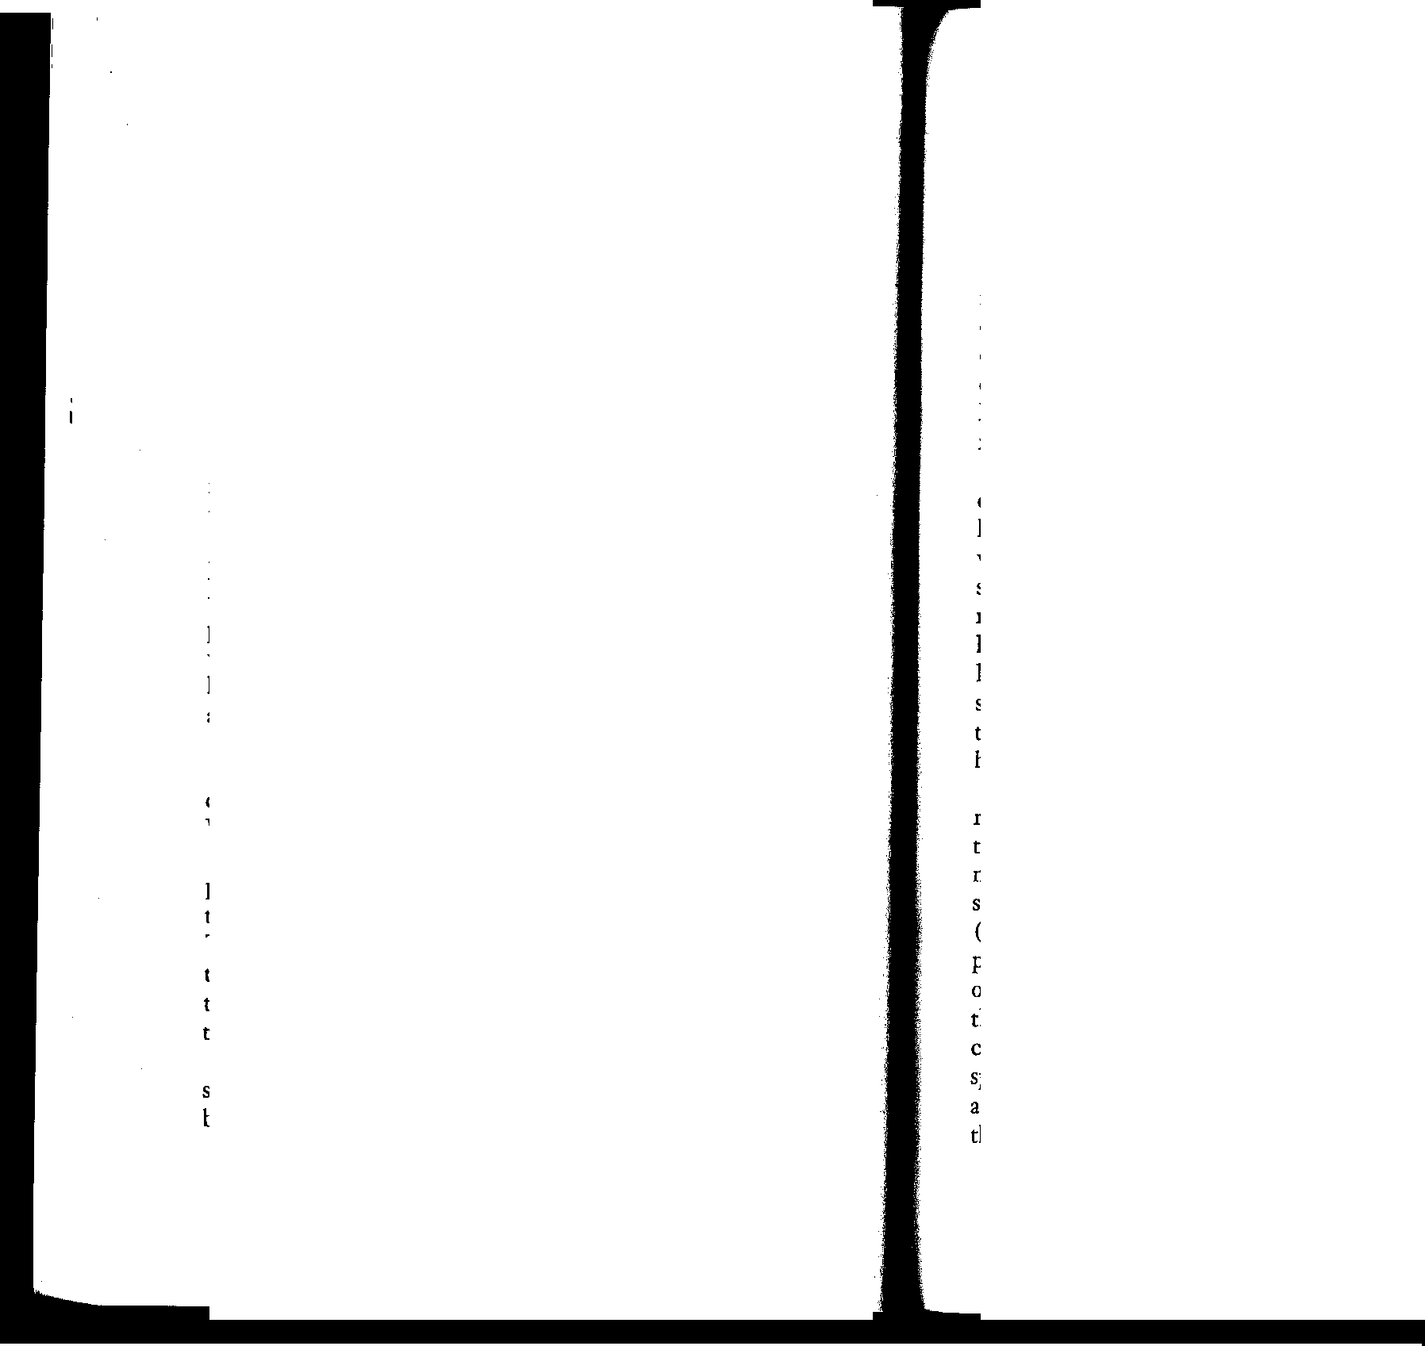

Use of animal systemics has concentrated chiefly on control of the cattle grub, a damaging parasite of livestock. Extreme care must be used in order to create an insecticidal effect in the blood and tissues of the host without setting up a fatal poisoning. The balance is delicate and government veterinarians have found that repeated small doses can gradually deplete an ani­ mal's supply of the protective enzyme cholinesterase, so that without warning a minute additional dose will cause poisoning. There are strong indications that fields closer to our daily lives are being opened up. You may now give your dog a pill which, it is claimed, will rid him of fleas by making his blood poisonous to them. The hazards discovered in treating cattle would presumably apply to the dog. As yet no one seems to have proposed a human systemic that would make us lethal to

a mosquito. Perhaps this is the next step.

So far in this chapter we have been discussing the deadly chemicals that are being used in ur war against the insects. What of our simultaneous war against the weeds?

The desire for a quick and easy method of killing unwanted plants has given rise to a large and growing array of chemicals that are known as herbicides, or, less formally, as weed killers. The story of how these chemicals are used and misused will be told in Chapter 6; the question that here concerns us is whether the weed killers are poisons and whether their use is contributing to the poisoning of the environment.

The legend that the herbicides are toxic only to plants and so pose no threat to animal life has been widely disseminated, but unfortunately it is not true. The plant killers include a large

variety of chemicals that act on animal tissue as well as on vegetation. They vary greatly in their action on the organism. Some are general poisons, some are powerful stimulants of me­ tabolism, causing a fatal rise in body temperature, some induce malignant tumors either alone or in partnership with other chemicals, some strike at the genetic material of the race by causing gene mutations. The herbicides, then, like the insecti­ cides, include some very dangerous chemicals, and their care­ less use in the belief that they are "safe" can have disastrous results.

Despite the competition of a constant stream of new chemi­ cals issuing from the laboratories, arsenic compounds are still liberally used, both as insecticides (as mentioned above) and as weed killers, where they usually take the chemical form of sodium arsenite. The history of their use is not reassuring. As roadside sprays, they have cost many a farmer his cow and killed uncounted numbers of wild creatures. As aquatic weed killers in lakes and reservoirs they have made public waters un­ suitable for drinking or even for swimming. As a spray applied to potato fields to destroy the vines they have taken a toll of human and nonhuman life.

In England this latter practice developed about 1951 as a result of a shortage of sulfuric acid, formerly used to burn off the potato vines. The Ministry of Agriculture considered it necessary to give warning of the hazard of going into the arsenic­ sprayed fields, but the warning was not understood by the cattle (nor, we must assume, by the wild animals and birds) and re­ ports of cattle poisoned by the arsenic sprays came with monot­ onous regularity. When death came also to a farmer's wife through arsenic-contaminated water, one of the major English chemical companies (in 1959) stopped production of arsenical sprays and called in supplies already in the hands of dealers, and shortly thereafter the Ministry of Agriculture announced that because of high risks to people and cattle restrictions on the

36 SILENT SPRING



use of arsenites would be imposed. In 1961, the Australian government announced a similar ban. No such restrictions im­ pede the use of these poisons in the United States, however.

. Some of the "dinitro" compounds are also used as herbicides. They are rated as among the most dangerous materials of this type in use in the United States. Dinitrophenol is a strong metabolic stimulant. For this reason it was at one time used as a reducing drug, but the margin between the slimming dose and that required to poison or kill was slight - so slight that several patients died and many suffered permanent injury before use of the drug was finally halted.

A related chemical, pentachlorophenol, sometimes known as "penta," is used as a weed killer as w.ell as an insecticide, often• being sprayed along railroad tracks and in waste areas. Penta is extremely toxic to a wide variety of organisms from bacteri.a to man. Like the dinitros, it interferes, often fatally, with the body's source of energy, so that the affected organism almost literally burns itself up. Its fearful power is illustrated in a fatal accident recently reported by the California Department of Health. A tank truck driver was preparing a cotton defoliant by mixing diesel oil with pentachlorophenol. As he was draw­ ing the concentrated chemical out of a drum, the spigot ac­ cidentally toppled back. He reached in with his bare hand to regain the spigot. Although he washed immediately, he became acutely ill and died the next day.

While the results of weed killers such as sodium arsenite or the phenols are grossly obvious, some other herbicides are more insidious in their effects. For example, the now famous cran­ berry-weed-killer aminotriazole, or amitrol, is rated as having relatively low toxicity. But in the long run its tendency to cause malignant tumors of the thyroid may be far more significant for wildlife and perhaps also for man.

Among the herbicides are some that are classified as "muta­ gens," or agents capable of modifying the genes, the materials

ELIXIRS OF DEATH 37

of heredity. We are rightly appalled by the genetic effects of radiation; how then, can we be indifferent to the same effect in chemicals that we disseminate widely in our environment?